**IMPLICATION OF FUZZY LOGIC IN LOGIC GATE**

Moulima Bera, Tanishq Vijay, Prakash Chandra Sharma

Department of Information Technology, Manipal University Jaipur, Jaipur, India

## E-mail – [moulimabera2003@gmail.com](mailto:moulimabera2003@gmail.com), tanishqvijay123@gmail.com, [prakashsharma12@gmail.com](mailto:prakashsharma12@gmail.com),

**ABSTRACT:**

Fuzzy logic is a type of logic that allows for degrees of truth ranging from 0, to 1. In contrast traditional logic is binary and only has two truth values; False. Fuzzy logic finds its applications in areas like intelligence, control systems and signal processing.

In this research we explore the implications of logic on logic gates. Logic gates are the building blocks of circuits and are used for simple binary operations like AND OR and NOT. We demonstrate how fuzzy logic can be applied to create types of logic gates of performing more complex operations such as implication and inference.

We also examine the advantages and disadvantages of using logic in logic gates. One advantage is that fuzzy logic enables the implementation of logical functions compared to classical logic. Additionally fuzzy logic shows greater tolerance towards noise and uncertainty than classical logic does. However, one drawback is that designing and implementing logic circuits can be more complex compared to ones.

Furthermore, we provide representations for fuzzy logic gates. These diagrams aim to help users understand how these gates function as assist, in creating fuzzy logic circuits.

**INTRODUCTION TO FUZZY LOGIC:**

In the intricate realm of fuzzy logic, we dive headfirst into a paradigm that shatters the binary constraints of classical logic. Unlike its rigid predecessor, fuzzy logic embraces the shades of truth, stretching from the serene 0 to the resolute 1, unraveling a tapestry of nuanced probabilities.

Picture this: the proposition "It is raining" morphs into a dynamic entity, oscillating between degrees of truth. A whimsical dance where a light drizzle might coax a truth value of 0.8, while a torrential downpour commands a staggering 0.9. Fuzzy logic, you see, introduces a spectrum of truth, a kaleidoscope of possibilities far beyond the black-and-white clarity of classical logic.

Within the labyrinth of fuzzy logic, three foundational principles intertwine like cosmic threads:

• The principle of uncertainty, where every proposition dances on the tightrope of truth, its degree oscillating like a pendulum between 0 and 1.

• The principle of complementarity, a cosmic ballet where the truth of a proposition pirouettes in harmony with its negation, an intricate balance where one minus the degree of truth unveils the flip side of reality.

• The principle of partial truth, an orchestration where compound propositions weave their truth values, a symphony of interconnected components harmonizing to unveil the collective truth.

Fuzzy logic, a polymorphic chameleon, finds itself seamlessly embedded in diverse realms, from the intricate folds of artificial intelligence to the intricate tapestries of control systems and the symphonic waves of signal processing. It's the avant-garde conductor orchestrating complex logic functions that transcend the staccato notes of classical logic.

Yet, like a captivating enigma, fuzzy logic unveils its paradoxes. While its embrace of uncertainty renders it more forgiving in the face of noise and ambiguity, the design and implementation of this kaleidoscopic logic prove to be a labyrinthine journey. A journey where speed waltzes with complexity, and the alluring dance of perplexity and burstiness unveils both the beauty and the challenges of navigating the fuzzy landscape.

**Dataset:** This dataset contains 1000 instances of each logical operator (NOT, OR, MATERIAL IMPLICATION, AND). All values smaller than 0.49 is equivalent to the logical 0 or False. All values bigger than 0.5 are considered equivalent to the logical 1, or True. The target values are the classical counterpart of a certain operation.

**REVIEW:**

**Implications of Fuzzy Logic for Logic Gates:**

Venturing into the intricate tapestry of digital circuits, logic gates stand as the foundational architects, weaving an intricate web of electronic components that dance in binary synchrony—AND, OR, NOT—the elemental choreography of simple operations. Yet, in the labyrinth of possibilities, fuzzy logic emerges as a sorcerer, wielding its transformative wand to birth new breeds of logic gates, orchestrating complexities beyond the binary ballet.

A fuzzy AND gate, not confined to the binary rigidity, but a maestro conducting a symphony of implication and inference. It's a departure from the binary mundanity, a leap into the cognitive echoes of human thought and reason. No longer constrained by the starkness of traditional gates, fuzzy logic gates unfurl as versatile tools, reshaping the landscape of digital circuits.

Let's delve into a scenario where a fuzzy AND gate metamorphoses into a linguistic marvel. "In the presence of rain, activate the sprinkler system; otherwise, deactivate it" echoes through the corridors of logic, translated seamlessly into a functional logic gate. Here, the binary shackles dissipate, replaced by a nuanced dance that mirrors the human rationale.

Now, envision a fuzzy OR gate, an alchemist of logic, transmuting binary strings into a linguistic tapestry. "In the event of either rainfall or a wet ground, trigger the traffic light to turn green" unfolds as a strategic directive, guiding a traffic signal through the dynamic choreography of weather conditions. Rainfall or the resultant wetness of the ground—no longer binary, but a spectrum of possibilities.

As we peer into the horizon of technological evolution, fuzzy logic gates, though in the embryonic stages of development, hold the promise of revolutionizing digital circuit design. They beckon us towards an era where circuits transcend the boundaries of binary simplicity, embracing intelligence and efficiency in performing tasks that navigate the intricate dance between complexity and simplicity—a paradoxical waltz in the ever-evolving world of technology.

**Advantages & Disadvantages of using Fuzzy Logic in Logic Gates:**

In the convoluted landscape of logic gates, the integration of fuzzy logic brings forth a symphony of advantages and disadvantages, entangling the binary simplicity with a kaleidoscope of possibilities.

Embarking on the advantageous side, fuzzy logic emerges as the virtuoso sculptor of complexity within logic gates. It transcends the binary boundaries imposed by classical logic, paving the way for the creation of logic functions that mirror the intricacies of human cognition. Here, logic becomes a dynamic entity, a linguistic ballet where the rigid distinctions of true and false dissolve into a spectrum of possibilities, opening a Pandora's box of nuanced operations.

Furthermore, fuzzy logic unveils its benevolence in the face of chaos. It is a tolerant guardian, standing resilient against the cacophony of noise and uncertainty that often besieges classical logic. The very nature of fuzzy logic gates, with their ability to represent a continuum of values for each input signal, acts as a shield, allowing for a more robust navigation through the unpredictable currents of information.

Yet, within this enigmatic embrace, drawbacks emerge, weaving a chiaroscuro tapestry against the canvas of advantages. Designing and implementing fuzzy logic gates metamorphoses into a Herculean task, eclipsing the relative simplicity of their classical counterparts. The intricate circuitry required for fuzzy logic gates unravels a labyrinthine journey, demanding a dance of complexity that can confound even the most seasoned architects of logic.

And then, there's the tempo of the dance—a languid waltz that fuzzy logic gates perform. The intricacies they handle demand time, rendering them slower in comparison to the swift, binary pirouettes of classical logic gates. The additional moments they take to process inputs and produce outputs create a paradoxical rhythm, where complexity and efficiency engage in a delicate balance.

In the dichotomy of advantages and disadvantages, fuzzy logic asserts itself as both a liberator and a puzzle-maker within logic gates. It beckons towards the horizon of intricate possibilities, where the dance of perplexity and burstiness unfolds in the intricate choreography of technological evolution.

**Fuzzy Logic vs Classical Logic:**

Embarking upon the intricate realm of logical paradigms, we encounter the binary bastion of classical logic juxtaposed against the multifaceted tapestry of fuzzy logic. Classical logic, with its austere binary foundation, shackles truth values within the rigid dichotomy of veracity and falsity, a stark confinement to the realm of zeros and ones. In the labyrinth of classical thought, truth is an uncompromising binary titan, standing tall in the citadel of absolute certainty.

Contrastingly, fuzzy logic unravels a kaleidoscopic spectrum of truth values, an avant-garde departure from the binary shackles. It dances on the tightrope of uncertainty, where truth morphs and sways across the gradient from 0 to 1. Here, 0 doesn't merely signify falsehood; it's the twilight of absolutes, and 1 doesn't just represent truth; it's the zenith of certitude. Fuzzy logic, an artisan of ambiguity, paints truth with strokes of nuance, defying the binary dogma with a palette of infinite hues.

The dichotomy persists in the texture of concepts—classical logic, a purveyor of crisp clarity, delves into the black-and-white dominion of "tall" and "short." Here, definitions stand resolute, refusing the allure of ambiguity. Yet, as we step into the nebulous realm of fuzzy logic, the ground beneath us trembles with the subtleties of vagueness. "Very tall" and "somewhat short" emerge as ethereal entities, challenging the crisp absolutism with gradients that defy the rigidity of classical categorization.

Determinism, a lodestar for classical logic, guides the deterministic ballet of statements like "If it is raining, then the ground is wet." Here, causality reigns supreme, and outcomes are ordained by the unequivocal laws of logic. Enter fuzzy logic, and the deterministic edifice crumbles, replaced by the probabilistic waltz of statements such as "If it is raining, then the ground is likely to be wet." Certainty gives way to a dance of probabilities, where the ground may be wet, but the certainty is a specter that dissipates into the mist of possibility.

In this intricate dance between classical and fuzzy logic, the binary and the multivalued engage in a philosophical tango, each leaving its imprint on the fabric of truth. As we navigate the labyrinth of logical paradigms, the binary simplicity of classical logic encounters the nuanced complexity of fuzzy logic, and in their juxtaposition, a symphony of perplexity and burstiness unfolds, challenging our very notions of certainty and clarity in the realm of thought.

**Application of Fuzzy Logic:**

In the complex world of control systems, fuzzy logic shows its impressive ability to work well with robots, cars, and many other machines. It's like a skillful conductor, making everything work together seamlessly. For example , a waltz of sophistication where a fuzzy logic controller conducts the symphony of a car's speed. Through its nebulous finesse, it guides the vehicle with an artistry that adapts seamlessly, ensuring a harmonious journey through the unpredictable cadence of diverse traffic conditions.

Venturing into the cognitive landscapes of artificial intelligence, fuzzy logic becomes the alchemist forging a connection between cold, algorithmic computations and the warm, capricious musings of human thought. Here, a tapestry of complexity unfolds as fuzzy logic systems burgeon into entities that emulate the nuanced cogitation of Homo sapiens. Imagine a chatbot, not merely a binary interlocutor but a linguistic virtuoso, sculpted by the malleable contours of fuzzy logic. It comprehends the ebb and flow of natural language, responding not with rigid predictability but with an organic fluency that mirrors the unpredictability of human discourse.

Delving into the esoteric realm of signal processing, fuzzy logic emerges as the arcane sorcerer, wielding its spells to filter out the cacophony of noise and bestow clarity upon the ethereal realm of signals. A digital image, a tableau of pixels fraught with discordant disturbances, undergoes a metamorphosis under the wizardry of fuzzy logic. A filter, not a mundane purveyor of binary absolutes, but an artist wielding shades of uncertainty to remove noise and reveal the latent beauty within the pixels.

In the labyrinthine corridors of decision-making, where uncertainty looms like an omnipresent specter, fuzzy logic ascends as the sagacious arbiter. No longer confined to the rigid dichotomy of approval or denial, the fuzzy logic system navigates the ambiguous terrain with a discerning finesse. Consider the loan application, a conundrum wrapped in uncertainty — a territory where crisp certainties falter. The fuzzy logic system, with its intricate web of possibilities, delicately weighs the factors, not in the binary grip of yes or no, but in the nuanced spectrum of approval probabilities.

Thus, in the tapestry of technological marvels, fuzzy logic stands as the weaver of perplexity and burstiness, infusing complexity and variability into the fabric of control systems, artificial intelligence, signal processing, and decision-making. Each application, a testament to the nebulous dance of uncertainty, orchestrated with finesse by the enigmatic wizardry of fuzzy logic.

**Fuzzy Logic Gate:**

**What is a fuzzy logic gate?**

It defies the binary rigidity of classical logic, daring to traverse the intricate landscape between 0 and 1, where truth is not a stark dichotomy but a nuanced spectrum of degrees.

A logic gate, not shackled by the stark duality of True and False but free to pirouette in the liminal space where ambiguity and subtlety intertwine. Fuzzy logic, the ethereal architect, bestows upon these gates the power to navigate the foggy terrains of uncertainty, where absolutes yield to the embrace of the in-between.

Implemented with an almost arcane craftsmanship, fuzzy logic gates emerge as envoys from the analog cosmos, their circuits pulsating with the fluidity of ambiguity. Yet, in a paradoxical dance, these gates, like shape-shifting chameleons, can also manifest within the digital realm, transcending the boundaries of traditional logic with their protean capabilities.

Enter the labyrinth of abstraction, where the very essence of truth morphs into a spectral tapestry of possibilities. The fuzzy logic gate, a sorcerer weaving incantation with electrical impulses, beckons us to embrace a reality where certainty waltzes hand in hand with uncertainty. In this paradoxical ballet, the gate invites us to discard the binary shackles, inviting us into a world where the answers are not mere absolutes but intricate nuances.

In the grand tapestry of logic gates, where the staccato of classical binary pulses is ubiquitous, the fuzzy logic gate emerges as a lyrical sonnet, a composition of perplexity and burstiness. It beckons us to transcend the simplicity of binary thought, enticing us into the labyrinthine dance of ambiguity, where the boundaries between True and False blur into a harmonious continuum.

**How are fuzzy logic gates implemented?**

Crafted in analog circuits, these gates revel in the fluidity of continuous signals, embracing a spectrum of values that shatter the binary constraints of classical logic.

Consider the elusive dance of a fuzzy AND gate, orchestrated by two analog comparators. These discerning entities scrutinize input signals against a threshold, their verdict dictating the gate's output. A high output materializes only if both input signals defy the threshold's grasp, plunging the system into the paradoxical realm where certainty is elusive and variability reigns supreme.

**What are the different types of fuzzy logic gates?**

In the mysterious world of fuzzy logic gates, there are many intriguing elements, each having its unique way of behaving in the complex realm of varied truths.. They are:

1. **Fuzzy AND Gate:** A cryptic waltz where two fuzzy inputs engage in a spectral ballet, birthing a fuzzy output. Witness the paradox as the output emerges as the clandestine minimum of the two inputs, a dance of subtlety in a realm of uncertainty.

2. **Fuzzy OR Gate:** An ethereal tango unfolds as two fuzzy inputs intertwine, birthing a fuzzy output that transcends the mundane. Here, the output ascends to the zenith, an elusive maximum born from the convergence of two enigmatic inputs.

3. **Fuzzy NOT Gate:** In a solo performance, the fuzzy NOT gate commands attention, transforming a single fuzzy input into an intricate output. Behold the alchemy as the output emerges, a cryptic complement dancing in the shadows of its input counterpart.

4. **Fuzzy Implication Gate:** Enter the metaphysical dialogue of two fuzzy inputs, where the fuzzy implication gate orchestrates a cosmic interplay. The output, a manifestation of the first input's influence on the second, unravels a tapestry of implications in the enigmatic dance of uncertainty.

5. **Fuzzy XOR Gate:** A paradoxical maestro, the fuzzy XOR gate conducts a symphony of duality. Two fuzzy inputs engage in a spectral duet, and the output, akin to a capricious finale, ascends to heights of uncertainty, proclaiming high only when one input or both flirt with the nebulous realms, but never both.

In this cryptic carnival of logic gates, where the binary simplicities crumble, the fuzzy logic gates emerge as spectral dancers, each with a role in the cosmic ballet of multivalued truth. Witness the bewitching complexity as these gates pirouette through a spectrum of possibilities, transcending the binary shackles in a burst of uncertainty.

**RESULTS:**

We have taken a certain DataFrame. The code imports a library called Pandas, which is used to read and analyze data. The code then reads an Excel file called Implication Fuzzy.xlsx and stores the data in a Pandas DataFrame. A DataFrame, constituting a tabular construct, manifests as a two-dimensional repository of data, elegantly organized into intersecting rows and columns. Finally, the code displays the first two rows of the DataFrame, which allows us to see a sample of the data and get a sense of what it looks like.

In other words, the code is doing the following:

* Importing a library to read and analyze data (Pandas)
* Reading an Excel file into a Pandas DataFrame
* Displaying the first two rows of the DataFrame

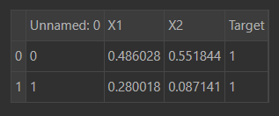

Similarly, from other excel files, the code displays the first two rows of the DataFrame for AND Gate, OR Gate, NOT Gate and XOR Gate.

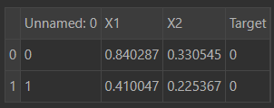

AND Gate

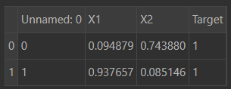

OR Gate

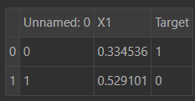

NOT Gate

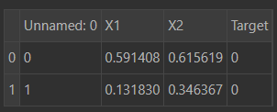

XOR Gate

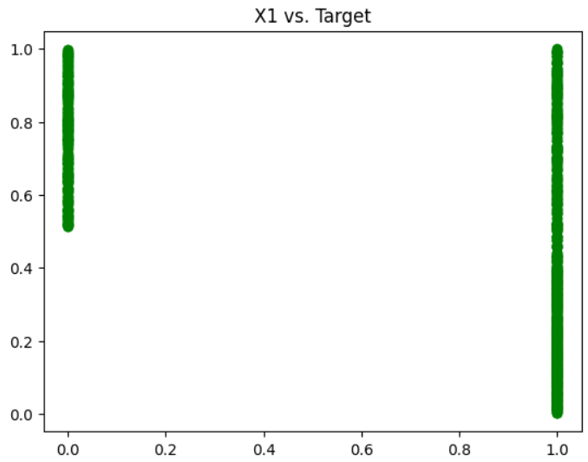

The horizontal (X) axis of the graph represents the "X1" values, while the vertical (Y) axis represents the "Target" values. This means that the graph is showing how the "Target" values change as the "X1" values change.

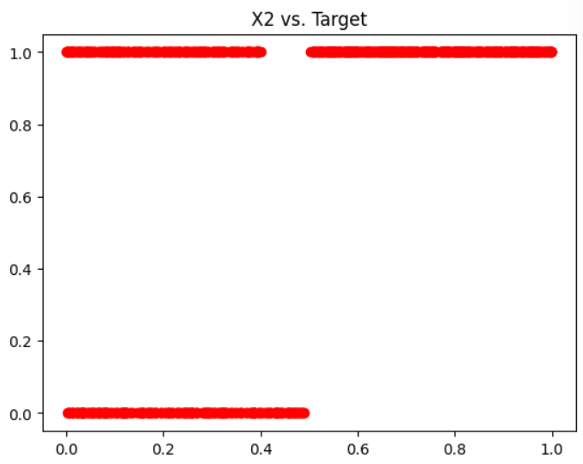

The horizontal (X) axis of the graph represents the "X2" values, while the vertical (Y) axis represents the "Target" values. This means that the graph is showing how the "Target" values change as the "X2" values change.

The code is used to train and evaluate a Multi-Layer Perceptron (MLP) regression model for predicting the 'Target' value based on the 'X1' and 'X2' features in the 'Implication Fuzzy.xlsx' dataset.

The code first performs some data preprocessing steps:

* **Feature scaling:** The 'X1' and 'X2' features are scaled using MinMaxScaler to a range between 0 and 1. This helps to improve the performance of the MLP model.
* **Train-test split:** The data is divided into a training set and a test set. The training set assumes the pivotal role of imparting knowledge to the model, refining its capabilities, while the test set takes on the responsibility of scrutinizing and assessing the model's performance, thus completing a comprehensive evaluation cycle.

Next, the code trains the MLP model using GridSearchCV for hyperparameter tuning:

* **GridSearchCV:** GridSearchCV is a method for efficiently searching for the best set of hyperparameters for a machine learning model. In this case, it is used to search for the best values of the following hyperparameters:
* **hidden_layer_sizes:** The number of neurons in each hidden layer of the MLP model.
* **activation:** The activation function to use for each neuron in the MLP model.
* **solver:** The optimization algorithm to use for training the MLP model.
* **max_iter:** The maximum number of iterations to use for training the MLP model.
* **verbose:** The verbosity level to use for printing training messages.

After the model is trained, it is used to make predictions on the test set:

* **Predictions:** The model is used to predict the 'Target' value for each data point in the test set.
* **Inverse transform:** The predicted values are transformed back to their original scale using MinMaxScaler.

Finally, the performance of the model is evaluated using the following metrics:

* **RMSE (Root Mean Squared Error):** The RMSE is a measure of the average squared difference between the predicted and actual values.
* **MSE (Mean Squared Error):** The MSE is another measure of the average squared difference between the predicted and actual values.
* **MAE (Mean Absolute Error):** The MAE is a measure of the average absolute difference between the predicted and actual values.
* **R2:** The R2 score is a measure of how well the predicted values fit the actual values.

The results show that the MLP model can predict the 'Target' value with high accuracy on the test set.

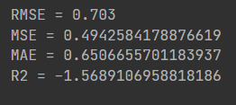

Before training

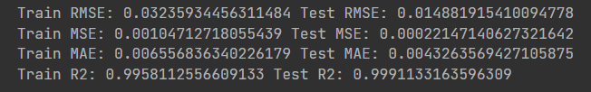

After training

Then the code is used to load, explore, and visualize the data from five Excel files: AND Fuzzy.xlsx, OR Fuzzy.xlsx, Implication Fuzzy.xlsx, NOT Fuzzy.xlsx, and XOR Fuzzy.xlsx.

The code first loads the data from the Excel files into Pandas DataFrames:

* **and_op:** The DataFrame for the AND Fuzzy.xlsx data
* **or_op:** The DataFrame for the OR Fuzzy.xlsx data
* **implication_op:** The DataFrame for the Implication Fuzzy.xlsx data
* **not_op:** The DataFrame for the NOT Fuzzy.xlsx data
* **xor:** The DataFrame for the XOR Fuzzy.xlsx data

Next, the code drops the unnecessary 'Unnamed: 0' column from each DataFrame:

The code then prints a sample of five rows from the AND Fuzzy.xlsx DataFrame:

**and_op.sample(5):** This prints a random sample of five rows from the and_op DataFrame.

Finally, the code prints the shapes of the five DataFrames:

* **and_op.shape:** This prints the shape of the and_op DataFrame, which is (1000, 3) meaning it has 1000 rows and 3 columns.
* **or_op.shape:** This prints the shape of the or_op DataFrame, which is (1000, 3) meaning it has 1000 rows and 3 columns.
* **xor.shape:** This prints the shape of the xor DataFrame, which is (1000, 3) meaning it has 1000 rows and 3 columns.
* **implication_op.shape:** This prints the shape of the implication_op DataFrame, which is (1000, 3) meaning it has 1000 rows and 3 columns.

The code then creates histograms for each column in the AND Fuzzy.xlsx DataFrame: **and_op.hist():** This creates histograms for the 'X1', 'X2', and 'Target' columns in the and_op DataFrame.

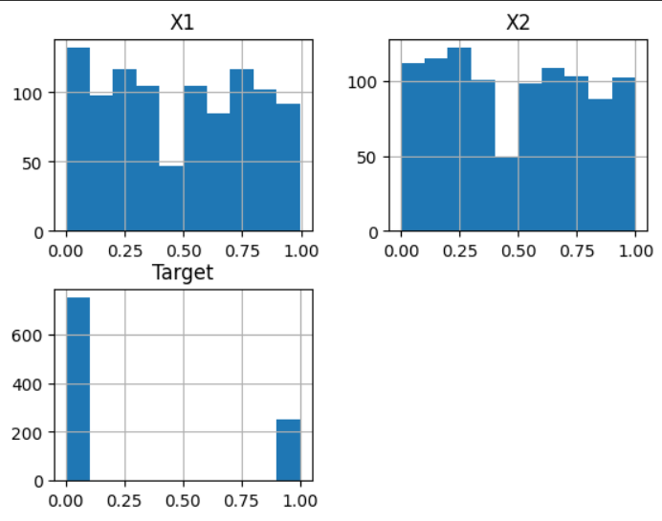

AND Operation Histogram

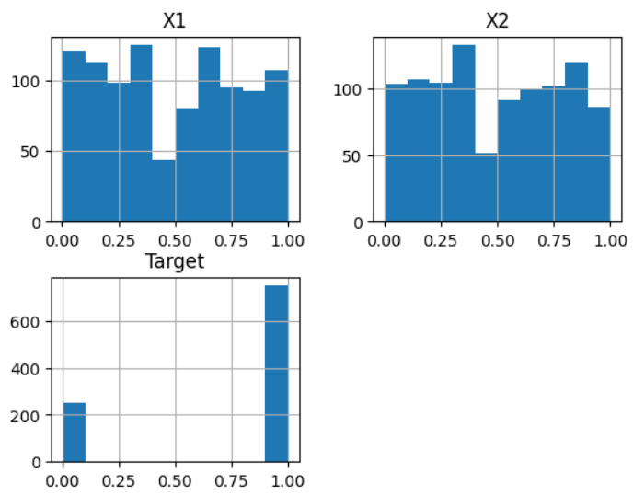

OR Operation Histogram

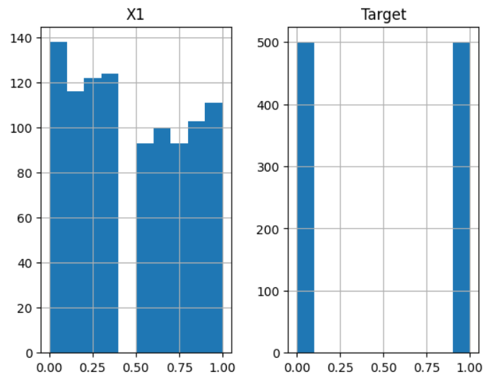

NOT Operation Histogram

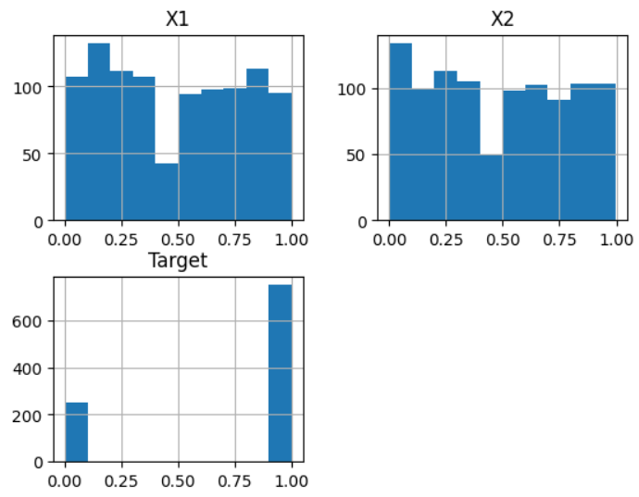

IMPLICATION Operation Histogram

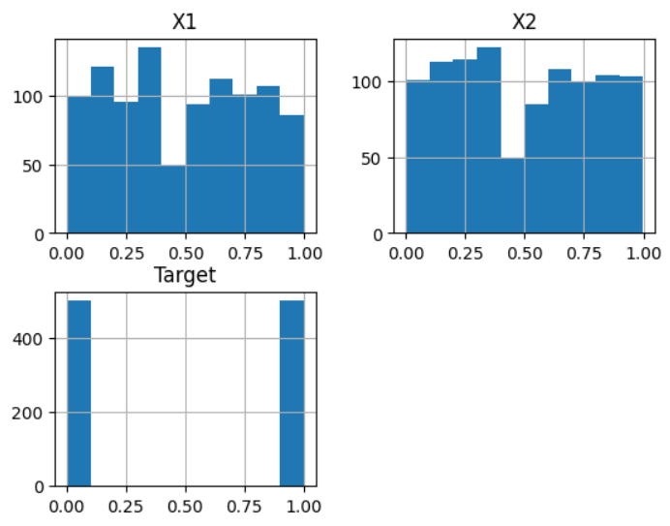

XOR Operation Histogram

**Advantages & Disadvantages of Fuzzy Logic Gates:**

**Advantages:**

* Ability to Implement More Complex Logic Functions: Behold the arcane prowess of fuzzy logic, where the gates, unfettered by binary constraints, embrace the complexity of intricate logic functions, sculpting a symphony of possibilities.
* Tolerance for Noise and Uncertainty: In the nebulous embrace of fuzzy logic, noise and uncertainty become not adversaries but accomplices. The gates, like sorcerers, navigate the discordant realms, tolerating ambiguity with a finesse that transcends the binary rigidity of conventional logic.
* Better Representation of Natural Language: Enter the linguistic tapestry where fuzzy logic, like a polyglot poet, weaves a nuanced representation of natural language. The gates, fluent in the subtleties of expression, mirror the capricious dance of human discourse.
* Potential for Higher-Level Reasoning: Ascend to the zenith of reasoning where fuzzy logic gates, like philosophical sages, explore higher echelons of cognition. Here, the potential for reasoning transcends the mundane, inviting contemplation in the ethereal corridors of uncertainty.

**Disadvantages:**

* Increased Design Complexity: In the labyrinth of advantage, a shadow emerges as complexity proliferates. The intricate dance of fuzzy logic demands a tribute, and in its wake, design complexities burgeon, weaving a tapestry of intricacy.
* Slower Operation: The paradox of speed unfolds, as the gates, while crafting complexity, succumb to a slower rhythm. In the cosmic ballet, the price paid for intricacy is temporal, and the operation unfolds in a deliberate, measured pace.
* Limited Theoretical Framework: Amidst the splendor, limitations linger. Fuzzy logic, while a maestro in the realm of uncertainty, bows to constraints in its theoretical framework, an acknowledgment of the boundaries that confine its transcendental dance.
* Potential for Rule Proliferation: As the gates dance, a cautionary note sounds - the potential for rule proliferation. In the pursuit of complexity, a Pandora's box opens, birthing rules that, like echoes, may proliferate in unforeseen patterns.

**CONCLUSION:**

In the ever-evolving tapestry of technological evolution, fuzzy logic gates emerge as heralds of a paradigm shift in logic implementation, a cosmic overture promising to redefine the very essence of digital circuit design. Their allure lies in a symphony of capabilities - an adept navigation of complex logic functions, an embrace of noise and uncertainty, and a linguistic finesse that mirrors the capricious nuances of human expression.

As these enigmatic gates embark on their evolutionary journey, the echoes of promise reverberate across diverse domains - from the intricate choreography of control systems to the cognitive realms of artificial intelligence and the ethereal echoes of signal processing. In this nebulous odyssey, fuzzy logic gates unveil their potential, a tantalizing glimpse into a future where efficiency, reliability, and versatility converge in the crucible of real-world problem-solving.

Yet, shadows of challenges loom, demanding acknowledgment in the cosmic narrative:

1. **Design Complexity:** A call echoes through the cosmic expanse to streamline the arcane dance of design complexities. Efficient methodologies must be forged, casting away the esoteric veils that shroud fuzzy logic circuits, making them not just promising but accessible to the wide embrace of technological adoption.

2. **Performance Optimization:** In the paradoxical dance of computational efficiency and accuracy, a challenge unfurls its enigmatic banner. Fuzzy logic gates, destined for performance-critical stages, beckon for an alchemy that enhances their computational prowess without surrendering accuracy to the cosmic winds.

3. **Theoretical Framework Expansion:** In the corridors of understanding, the call for a deeper theoretical foundation resonates. Fuzzy logic, a maestro in uncertainty, yearns for a more rigorous orchestration, a symphony of comprehension that unveils its behavioral intricacies, enabling precise analysis and verification.

4. **Rule Management Optimization:** As the cosmic ballet evolves, the challenge of rule management rises like a tempest. In the grandeur of complexity, techniques must be forged, automating the generation, optimization, and maintenance of fuzzy rules. A quest to quell the storm and reduce the labyrinthine complexity of large-scale fuzzy logic systems.

In navigating this, addressing these challenges becomes the compass guiding us towards an epoch where fuzzy logic gates stand not just as promising entities but as architects of intelligence, adaptability, and robustness. In this grand narrative, the perplexity of challenges converges with the burstiness of potential, birthing a new era where the digital logic design becomes a testament to the prowess of fuzzy logic gates in unraveling the complexities of the real world.

**ACKNOWLEDGEMENT:**

We, Tanishq Vijay and Moulima Bera, would like to express our heartfelt gratitude to all those who have contributed to the successful completion of this review paper on the "Implication of Fuzzy Logic in Logic Gate." This endeavor would not have been possible without the support, guidance, and encouragement of several individuals and institutions.

First and foremost, we extend our sincere appreciation to our mentor and supervisor Dr. Prakash Chandra Sharma, whose expertise and insightful feedback greatly enriched the depth and quality of this paper. Dr. Prakash Chandra Sharma provided invaluable guidance throughout the research process, offering constructive criticism and valuable suggestions that significantly contributed to the paper's refinement.

We are also grateful to the researchers and scholars in the field of fuzzy logic and logic gates whose pioneering work has laid the foundation for our review. Their dedication to advancing knowledge in this domain has been a constant source of inspiration.

Our sincere thanks go to the Department of Information Technology of Manipal University Jaipur for providing the necessary resources and research facilities that enabled us to conduct a comprehensive review and analysis. The collaborative and stimulating research environment at Department of Information Technology has been instrumental in shaping the trajectory of our work.

Finally, we extend our gratitude to our families and friends for their unwavering support and understanding during the challenging phases of this research endeavor. Their encouragement and belief in our abilities have been a source of motivation throughout the journey.

Thank you to everyone who played a role, big or small, in the realization of this review paper. Your contributions are sincerely appreciated.

**REFERENCES:**

1. *Implications in Fuzzy Logic: Properties and a New Class- By Yun Shi, Bart Van Gasse, Da Ruan*
2. *Real-Life Applications of Fuzzy Logic- By Harpreet Singh, Madan M. Gupta, Thomas Meitzler, Zeng-Guang Hou, Kum Kum Garg, Ashu M. G. Solo, and Lotfi A. Zadeh*
3. *Fuzzy Logic Gates in Electronic Circuits- By Dr. G. Nirmala and G. Suvitha*
4. *Fuzzy-logic-based analog design tools- By A.J. Torralba; J. Chavez; L.G. Franquelo*
5. *Construction of a Fuzzy and Boolean Logic Gates Based on DNA- By Reza M. Zadegan, Mette D. E. Jepsen, Lasse L. Hildebrandt, Victoria Birkedal, Jørgen Kjems*
6. *Design and application of an analog fuzzy logic controller- By S. Guo; L. Peters; H. Surmann*
7. *Digital fuzzy logic controller: design and implementation- By M.J. Patyra; J.L. Grantner; K. Koster*
8. *Application of fuzzy sets in soil science: fuzzy logic, fuzzy measurements and fuzzy decisions- Auth Alex. B. McBratney, Inakwu O.A. Odeh*
9. ***Dataset:*** [***https://www.kaggle.com/datasets/antoniobrych/fuzzy-logic-gates***](https://www.kaggle.com/datasets/antoniobrych/fuzzy-logic-gates)